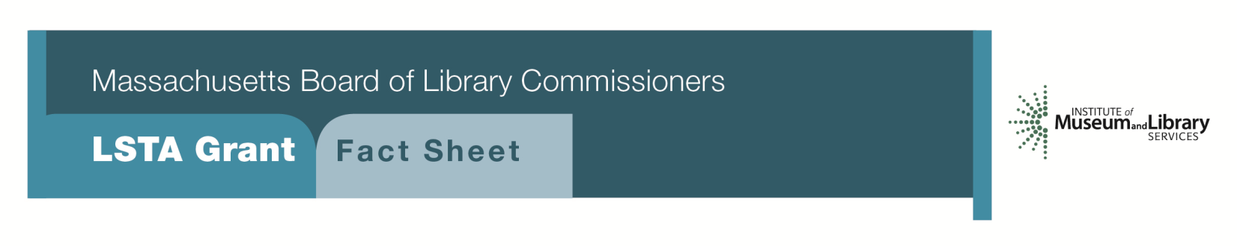
First Contact: Students & Primary Sources

PROGRAM DESCRIPTION
This project will provide grants up to $7500 for libraries to work with teachers and professors to promote the use and integration of primary sources (either as individual documents or as collections or parts of collections) in the classroom. Libraries and educators will identify appropriate collections, such as manuscripts, diaries, ledgers, account books, correspondence, oral histories, photographs, or any other primary sources and to make them available (either in the original or as digital surrogates) for classroom use. The primary sources will be fully integrated into the curriculum as an integral part of learning and research. Projects should also include visits to the repository, if possible, to introduce students to original research using special collections and to the proper care and handling of these original materials. While working with an individual teacher is most common, working with several teachers in the same grade would expand the impact and experience. The development of lesson plans, curricula, and other long-term projects, that can be used year after year, will help ensure the sustainability of the project(s).
PROGRAM ELIGIBILITY
Any public, school, or academic library that meets standard eligibility requirements for Direct Grant programs is eligible to apply. Libraries must have set a goal, formal or informal, of supporting curriculum and identified an interest in working with the local public (or private) school(s) (K-12) or academic discipline/professor(s) in post-secondary education to incorporate their primary sources into the curriculum. Letters of commitment from the school or college/university will be required as part of the application.
PRIORITIES AND FUNDING
It will be important to document how the use of primary resources will enhance the curriculum and contribute to critical thinking and analysis of the contents. Libraries may apply for grants of up to $7,500 to plan and implement such a project. Grant funds may be used to support a limited number of staff hours, provide student transportation, support selected hours for an educator to work on the project, provide support to ensure that the documents are arranged and described, produce and/or distribute digital copies of materials, and purchase preservation supplies to protect the documents. This may be a one or a two-year project.

INTERESTED?
Applicants must submit a Letter of Intent for with “First Contact: Students & Primary Sources” option checked off. If you need more information about this program, call Gregor Trinkaus-Randall at the MBLC at (800) 952-7403 ext. 236 or email gregor.trinkaus-randall@state.ma.us.
BACKGROUND
There is a growing movement throughout the country to introduce students, at all levels (K-12 and post-secondary) to the use of primary sources during their studies. This process stimulates critical thinking and provides an opportunity for students to experience the thrill of learning about history, society, social mores, economics, etc. by consulting the original documents (or digital surrogates). Massachusetts has a rich history that is documented in many libraries, historical societies, archives, and colleges. This plethora of sources that document the stories of the towns or regions can be discovered through the use of original documents. Although many of these holdings are still “hidden” because they have not yet been arranged and described, there are still many other collections that are available to researchers and students. This grant opportunity will provide support to facilitate and enhance the use of these collections in support of educational goals.
2018-2022 MASSACHUSETTS LIBRARY SERVICES & TECHNOLOGY ACT FIVE YEAR PLAN
Goal 2: Enabling Access
Objective 2: Improve Users’ Ability to Obtain and/or Use Information Resources

