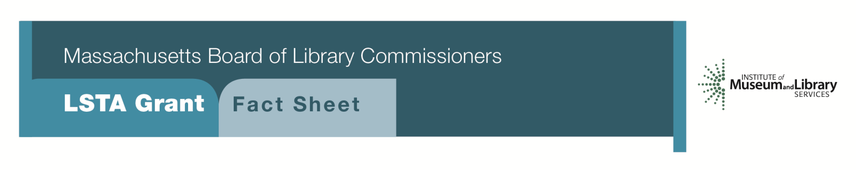
Go Local: Building Communities & Collections

PROGRAM DESCRIPTION
Libraries have a key role to play in capturing, collecting, and making community stories available and meaningful. Libraries can be at the center of community celebrations and historic events and create valuable records of those events in traditional and new formats: from pamphlets and written histories to podcasts, video recordings, oral histories, online exhibits, and more with grants from $7500 to $15,000. Massachusetts libraries can draw on their strength in this unique niche by developing projects that use historical documents and artifacts to make new stories and/or generate new records by creating and participating in community events that build the local story.

Libraries have access to readily-available traditional and easy-to-use new tools to record and document community stories that build a history and shared identity. Librarians know how to digitize and create metadata for access. Libraries can bring people together to share stories, and to engage volunteers in helping with projects that bridge generations and overcome socio-economic divisions. Examples of projects might include collecting oral or video histories focused on a shared theme or event; scanning and digitizing personal collections of local significance that would be made accessible through appropriate cataloging; “Mass. Memories Road Show”- style events that enrich understanding of individual and family stories, and show people how to care for their precious papers, documents, and photographs. Other possibilities are projects among libraries in communities with a common background, history, industry, or immigration stories. Projects might draw on and enrich local genealogical knowledge, help to identify and document knowledge of local landmarks, capture memories of a regional event, involve veterans and students, mark a town anniversary or significant event, and develop the library’s collection through the addition of traditional or digital content.

Projects should include a substantial partnership component, solid outreach to diverse and underserved groups or participants, and the creation of a lasting contribution to the local record.

ELIGIBILITY
Public libraries that meet standard eligibility requirements for direct grant programs are encouraged to apply. Funding ranges from $7,500 - $15,000 depending on project requirements and program design. Funds can be used for staff training in video/oral history techniques; a videographer, archivist, genealogist, or other specialist; additional part-time staff to work on the project; publishing/printing; file transfer and updates to digital formats; transcription, metadata creation, and limited funds may be used for equipment. Engaging volunteers in many aspects of a project is strongly encouraged. Well-designed projects will also provide opportunities for matching funds, other grant funding sources, and sponsorships. This can be a one or two-year grant depending on scale and scope.

Interested?
Applicants must submit a Letter of Intent form with the “Go Local: Building Communities & Collections” option checked off. For additional information about this program, please contact Ruth Urell at the MBLC at 1-800-952-7403 ext. 237 or email ruth.urell@state.ma.us.

2018-2022 Massachusetts Long Range Plan Goal & Objective
Goal 6: Connecting Communities: Promote libraries as centers of the community and support innovations that nurture civic engagement, strong democracy, and celebrate the community and its residents. Libraries provide common and inclusive spaces for everyone in the Commonwealth to share ideas and histories.
Objective 1: Improve people’s ability to participate in their community and in local issues.

