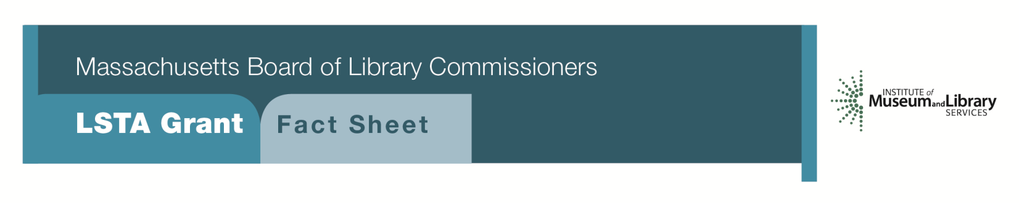
Pathways to Success

Program Description
Libraries have always provided resources for career development and job information. Funds are available for libraries to jump-start this increasingly important role. Libraries can initiate special focused programming, update current resources, and conduct promotional and outreach activities using LSTA grant funds.
Grants of up to $7,500 will be awarded to establish a work center/mentor program.
As part of the grant, libraries will be expected to:
- Develop a program offering help with resumes and job applications, interview techniques, and similar activities
- Create mentorship opportunities for job seekers
- Offer programming and workshops on topics such as changing careers, networking, continuing education options, etc.
- Collaborate with local agencies, organizations, and businesses

Interested?
Applicants must submit a Letter of Intent form with the “Pathways to Success” option checked off. For additional information about this program, please contact Lyndsay Forbes at the MBLC at 1-800-952-7403 ext. 252 or email lyndsay.forbes@state.ma.us.
Background
As reported by the Pew Research Center, “Many believe libraries should be pathways to economic opportunity, especially when it comes to providing resources for business development, jobs search and enhancing workforce skills...52% of all Americans 16 and older say libraries should ‘definitely’ create programs for local businesses or entrepreneurs.”

2018-2022 Massachusetts Long Range Plan Goal & Objective
Goal 4: Building the Workforce
Objective 1: Improve users’ ability to use resources and apply information for employment support

