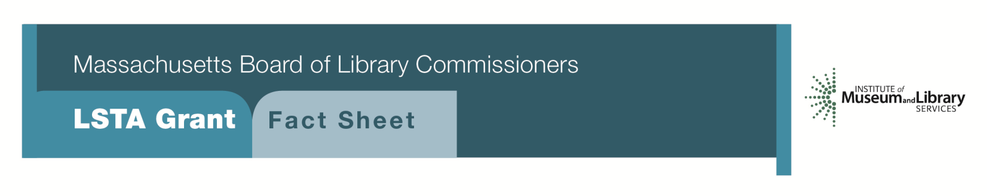
Preservation/Conservation of Library and Archival Material
PROGRAM DESCRIPTION
This program will support the preservation/conservation of library and/or archival research materials with significant long-term research value. Proof of ownership will be required for any project that involves the direct treatment of materials. Funded projects will require a commitment on the part of the library to return conserved materials to a storage location that meets recommended standards for the materials involved. Libraries will be awarded grants ranging from $5,000 to $30,000.
ELIGIBILITY
Any library or cooperating group that meets standard eligibility requirements for Direct Grant programs may apply. A cooperating group may apply on behalf of one or more of its members. To apply for funds, a library or cooperating group must have completed a Preservation Assessment within the past five years and developed a Preservation Long-Range Plan based on the consultant’s assessment report.
INTERESTED?
Applicants must submit a Letter of Intent form with the “Preservation/Conservation of Library and Archival Materials” option checked off. If you need more information about this program, contact Gregor Trinkaus-Randall at the MBLC at 1-800-952-7403 ext. 236 or by e-mail at gregor.trinkaus-randall@state.ma.us.

BACKGROUND
The documentary heritage of Massachusetts is essentially intact from its founding. Throughout the Commonwealth, repositories house irreplaceable collections of books, as well as private and public documents that serve as a rich resource for researchers. The 2011 report Massachusetts Connecting Collections Statewide Preservation Survey noted severe deficiencies in preservation of Massachusetts collections. Conservation work can address these gaps and prolong the lives of these collections.
2018-2022 Massachusetts Long-Range Plan Goal & Objective
Goal 2: Enabling Access
Objective 2: Improve users’ ability to obtain and/or use information resources

