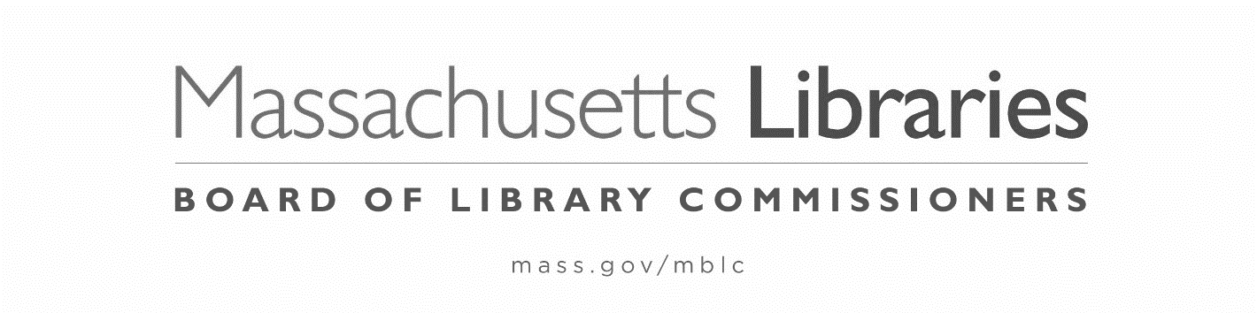

FY2024 STATE AID TO PUBLIC LIBRARIES
NOTIFICATION of REQUEST for HEARING
Pursuant to 801 C.M.R. 1.02, Informal Fair Hearing Rules

- This completed notification must be received in the Board of Library Commissioners Office within seven business days of the Board action being appealed.
- The hearing of the appeal will be placed on the agenda of the next regularly scheduled meeting of the Board of Library Commissioners.
- The Board will act on the appeal at the next Board meeting following the appeal hearing.

The municipality of Choose an item. is formally requesting a hearing to appeal one of the following:

☐ Denial of waiver of FY2024 Municipal Appropriation Requirement on February 2, 2024—appeal due February 17, 2024.
☐ Board action of Click here to enter a date. (date) regarding: ________________________________

Signature, Library Director: _______________________________________ Date: ___________

Signature, Library Trustee Chair: __________________________________ Date: ___________

Important Dates in the FY2024 State Aid to Public Libraries Program:
July 1, 2023 | Online submission of Annual Report Information Survey (ARIS) opens
August 2023 | State Aid to Public Libraries forms posted on website
August 7, 2023 | Online submission of the Financial Report opens
August 18, 2023 | Online submission of Annual Report Information Survey (ARIS) closes  ARIS due (signed pdf/print form)
Aug-Sept 2023 | State Aid workshops online. Waiver workshop online held separately
October 6, 2023 | Online submission of Financial Report closes  Financial Report due  State Aid Application and Compliance Form due (print form) for all libraries – including Multiple Independents  MAR waiver petition due, if necessary (print form)
November 2, 2023 | First group of municipalities meeting requirements presented to Board for certification and state aid awards are made
November 3, 2023 | Supporting documentation for MAR waiver petition due
December 7, 2023 | Second group of municipalities meeting requirements presented to Board for certification and state aid awards are made
January 1, 2024 | List of non-certified communities posted (updated later if MAR waiver applicants are denied certification)
January 4, 2024 | FY2024 MAR waiver applicants presented to the Board (includes in-person presentations)
February 1, 2024 | Board acts on FY2024 MAR waiver petitions
March 7, 2024 | Board hears any appeals of denial of FY2024 MAR
April 4, 2024 | Board acts on any appeals of denial of FY2024 MAR/FY2024 State Aid to Public Libraries program officially concludes

