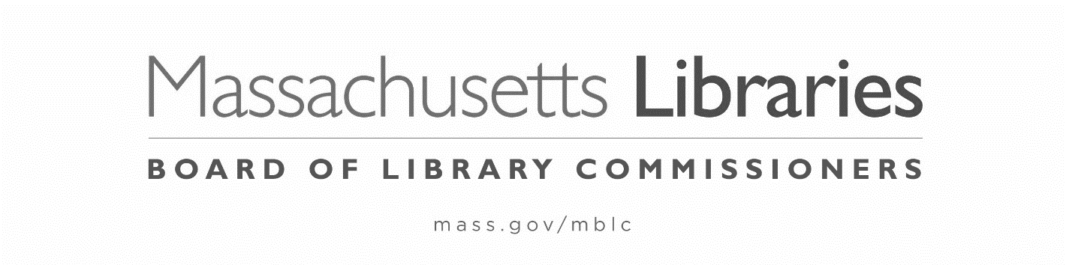

FY2024 STATE AID TO PUBLIC LIBRARIES
NOTIFICATION of NON-PARTICIPATION

The municipality of ___________________is not applying for the FY2024 State Aid to Public Libraries program.

Library Director’s Signature____________________________________________Date__________

Trustee Chair’s Signature_____________________________________________Date___________

THIS NOTIFICATION MUST BE
POSTMARKED BY OCTOBER 6, 2023
Important Dates in the FY2024 State Aid to Public Libraries Program:
July 1, 2023 | Online submission of Annual Report Information Survey (ARIS) opens
August 2023 | State Aid to Public Libraries forms posted on website
August 7, 2023 | Online submission of the Financial Report opens
August 18, 2023 | Online submission of Annual Report Information Survey (ARIS) closes  ARIS due (signed pdf/print form)
Aug-Sept 2023 | State Aid workshops online. Waiver workshop online held separately
October 6, 2023 | Online submission of Financial Report closes  Financial Report due  State Aid Application and Compliance Form due (print form) for all libraries – including Multiple Independents  MAR waiver petition due, if necessary (print form)
November 2, 2023 | First group of municipalities meeting requirements presented to Board for certification and state aid awards are made
November 3, 2023 | Supporting documentation for MAR waiver petition due
December 7, 2023 | Second group of municipalities meeting requirements presented to Board for certification and state aid awards are made
January 1, 2024 | List of non-certified communities posted (updated later if MAR waiver applicants are denied certification)
January 4, 2024 | FY2024 MAR waiver applicants presented to the Board (includes in-person presentations)
February 1, 2024 | Board acts on FY2024 MAR waiver petitions
March 7, 2024 | Board hears any appeals of denial of FY2024 MAR
April 4, 2024 | Board acts on any appeals of denial of FY2024 MAR/FY2024 State Aid to Public Libraries program officially concludes

